Memorial Day Cookout at the Pool!
Saturday June 11th
11:30 am – 3:30 pm
Benefiting Founders Bridge
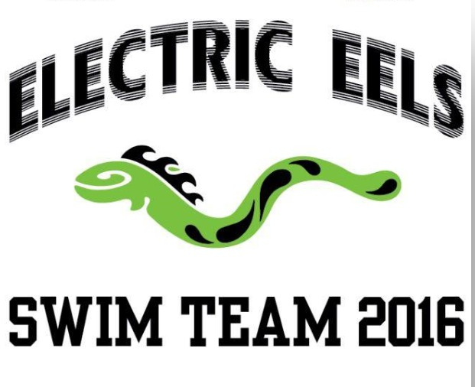
Meals Include:
Hamburger or Hot Dog
Salad (potato or pasta) Fruit, Chips and Dessert
Lemonade and Iced Tea

Cost:
Ham/veggie burger Meal $8 pre-paid / $10 day of
Hot Dog Meal $7 pre-paid / $9 day of

Return by Thursday, June 8th to:
Diane Koontz @16013 Pine Vale Place (box on front porch)
Checks payable to “Founders Bridge Swim Team”
Family Name: _________________________________________
Number of Meals: ____________
Hamburger __________ Veggieburger ___________ Hot Dog _________ Total Amount: ______

